Insert your name, centre number and candidate number into the header above.
Save this evidence document as evidence_ followed by your centre number_ candidate number. For example: evidence_ zz999_9999.doc
Screenshots or program listings must be copied into appropriate cells in the following tables.
Examiners must be able to read the contents including any screenshots without the use of a magnifying glass. Answers that are not readable or missing will not be awarded any marks.
Save this evidence document at regular intervals, for example, every 10 minutes.
Question 1
Part 1(a)
def ReadData():
try:
# Open the file in read mode
DataFile = open("Source files/Data.txt", "r")

# Local array consist of 45 items
DataItems = []

# Read the data from the file and store it in the array
for i in range(45):
DataItems.append(DataFile.readline().strip())

DataFile.close() # Close the file

return DataItems
except IOError:
print("Error reading from file")

Part 1(b)(i)
# Function to format the array takes in an array of strings
def FormatArray(DataArray):
OutputString = ""

# Loop through the array
for i in range(len(DataArray)):
# Add the item to the output string with a space between each item
OutputString = OutputString + DataArray[i] + " "

return OutputString

Part 1(b)(ii)
FileData = ReadData() # Read the data from the file
FormattedArray = FormatArray(FileData) # Print the formatted data

print(FormattedArray) # Print the formatted data

Part 1(b)(iii)
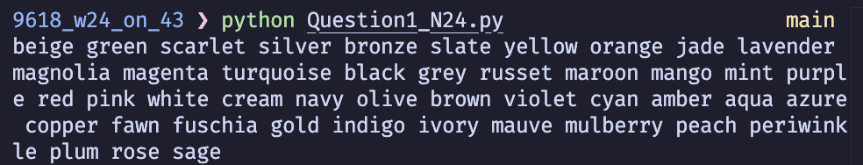

Part 1(c)
def CompareStrings(String1, String2):
maxLen = len(String1) if len(String1) > len(String2) else len(String2)

for i in range(maxLen):
if ord(String1[i]) < ord(String2[i]):
return 1
elif ord(String1[i]) > ord(String2[i]):
return 2
else:
continue

return -1

Part 1(d)(i)
def Bubble(DataArray):
data = DataArray[:]
n = len(data)

for i in range(n):
swapped = False
for j in range(0, n-i-1):
if CompareStrings(data[j], data[j + 1]) == 2:
data[j], data[j + 1] = data[j + 1], data[j]
swapped = True
if not swapped:
break

return data

Part 1(d)(ii)
SortedData = Bubble(FileData) # Sort the data
FormattedSortedData = FormatArray(SortedData) # Print the formatted data
print(FormattedSortedData) # Print the formatted data

Part 1(d)(iii)
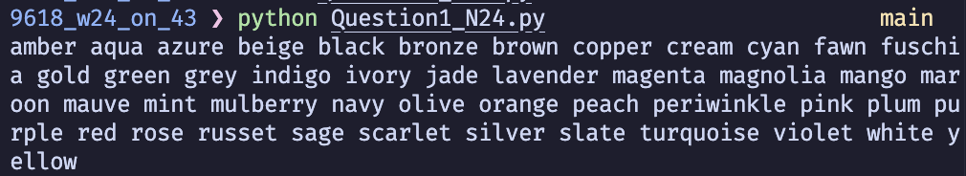

Question 2
Part 2(a)(i)
class Horse:

def __init__(self, Name, MaxFenceHeight, PercentageSuccess):
self.__Name = Name # Private attribute
self.__MaxFenceHeight = MaxFenceHeight # Private attribute
self.__PercentageSuccess = PercentageSuccess # Private attribute

Part 2(a)(ii)
def GetName(self):
return self.__Name

def GetMaxFenceHeight(self):
return self.__MaxFenceHeight

Part 2(b)(i)
Horses = [] # Array of 2 horses object
Horses.append(Horse("Beauty", 150, 72))
Horses.append(Horse("Jet", 160, 65))

# Output the name of both horses from the array
print(Horses[0].GetName())
print(Horses[1].GetName())

Part 2(b)(ii)
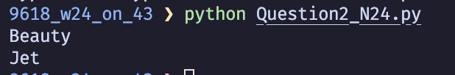

Part 2(c)(i)
class Fence:

def __init__(self, Height, Risk):
# Private attribute integer between 70 and 180
self.__Height = Height
# Private attribute integer between 1 and 5
self.__Risk = Risk

def GetHeight(self):
return self.__Height

def GetRisk(self):
return self.__Risk

Part 2(c)(ii)
Courses = [] # Array of 4 fence object

for i in range(4):
valid_input = False

while not valid_input:
# Read the height and risk of the fence
height = int(input("Enter the height of the fence: "))
risk = int(input("Enter the risk of the fence: "))

if height < 70 or height > 180 or risk < 1 or risk > 5:
print("Invalid input. Please enter a height between 70 and 180 and a risk between 1 and 5.")
else:
Courses.append(Fence(height, risk))
print("Fence added. \n")
valid_input = True

Part 2(d)
def Success(self, FenceHeight, RiskModifier):
if FenceHeight > self.__MaxFenceHeight:
return self.__PercentageSuccess * 0.2
else:
if RiskModifier == 1:
return self.__PercentageSuccess * 1
elif RiskModifier == 2:
return self.__PercentageSuccess * 0.9
elif RiskModifier == 3:
return self.__PercentageSuccess * 0.8
elif RiskModifier == 4:
return self.__PercentageSuccess * 0.7
elif RiskModifier == 5:
return self.__PercentageSuccess * 0.6
else:
return 0 # Invalid risk modifier

Part 2(e)(i)
for i in range(2):
for j in range(4):
print("The horse " + Horses[i].GetName() + " at fence " + str(j + 1) + " has a " + str(Horses[i].Success(Courses[j].GetHeight(), Courses[j].GetRisk())) + "% chance of success.")

Part 2(e)(ii)
average_success = [] # Array of average success rate for each horse

for i in range(2):
total_success = 0
for j in range(4):
print("The horse " + Horses[i].GetName() + " at fence " + str(j + 1) + " has a " + str(Horses[i].Success(Courses[j].GetHeight(), Courses[j].GetRisk())) + "% chance of success.")
total_success += Horses[i].Success(Courses[j].GetHeight(), Courses[j].GetRisk())

print("The horse " + Horses[i].GetName() + " has an average " + str(total_success/4) + "%. chance of jumping over all four fences. \n")

average_success.append(total_success/4)

if average_success[0] > average_success[1]:
print("The horse " + Horses[0].GetName() + " has the highest average chance of success ")
elif average_success[0] < average_success[1]:
print("The horse " + Horses[1].GetName() + " has the highest average chance of success ")

Part 2(e)(iii)
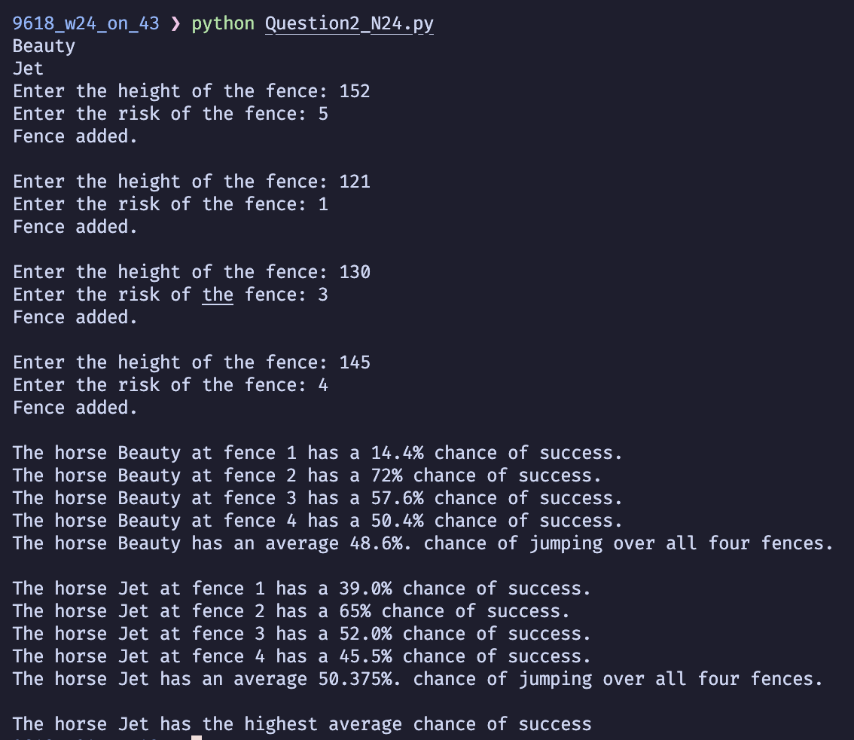

Question 3
Part 3(a)
LinkedList = [] # Global array
FirstNode = - 1
FirstEmpty = 0

for i in range(20):
LinkedList.append([-1, i + 1])

LinkedList[19][1] = -1

Part 3(b)
def InsertData():
global FirstNode
global FirstEmpty
global LinkedList

for i in range(5):
if FirstEmpty != -1:
NewNode = FirstEmpty
FirstEmpty = LinkedList[FirstEmpty][1]
LinkedList[NewNode][0] = int(input("Enter a number: "))
LinkedList[NewNode][1] = FirstNode
FirstNode = NewNode

Part 3(c)(i)
def OutputLinkedList():
global FirstNode
global LinkedList

CurrentNode = FirstNode

while CurrentNode != -1:
print(LinkedList[CurrentNode][0])
CurrentNode = LinkedList[CurrentNode][1]

Part 3(c)(ii)
InsertData()
OutputLinkedList()

Part 3(c)(iii)
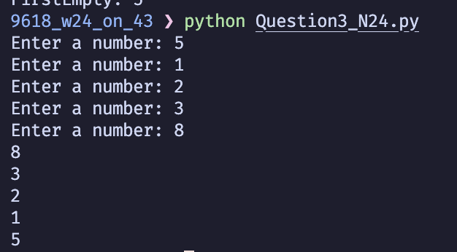

Part 3(d)(i)
def RemoveData(dataItem):
global FirstNode
global FirstEmpty
global LinkedList

CurrentNode = FirstNode
PreviousNode = -1

while CurrentNode != -1:
if LinkedList[CurrentNode][0] == dataItem:
if PreviousNode == -1:
FirstNode = LinkedList[CurrentNode][1]
else:
LinkedList[PreviousNode][1] = LinkedList[CurrentNode][1]
LinkedList[CurrentNode][1] = FirstEmpty
FirstEmpty = CurrentNode
return
PreviousNode = CurrentNode
CurrentNode = LinkedList[CurrentNode][1]

Part 3(d)(ii)
InsertData()
OutputLinkedList()
RemoveData(5)
print("After")
OutputLinkedList()

Part 3(d)(iii)
{Copy and paste the screenshot(s) for question 3(d)(iii) here}

